# CREATE IBM WATSON IOT PLATFORM AND DEVICE

|  |  |
| --- | --- |
| **TEAM ID** | **PNT2022TMID45918** |
| **PROJECT NAME** | **IOT BASED SMART CROP PROTECTION SYSTEM OF AGRICULTURE** |

1. To create the IBM Watson IOT platform and device

# STEPS:

1. create an IBM cloud account with the individual IBM id and password

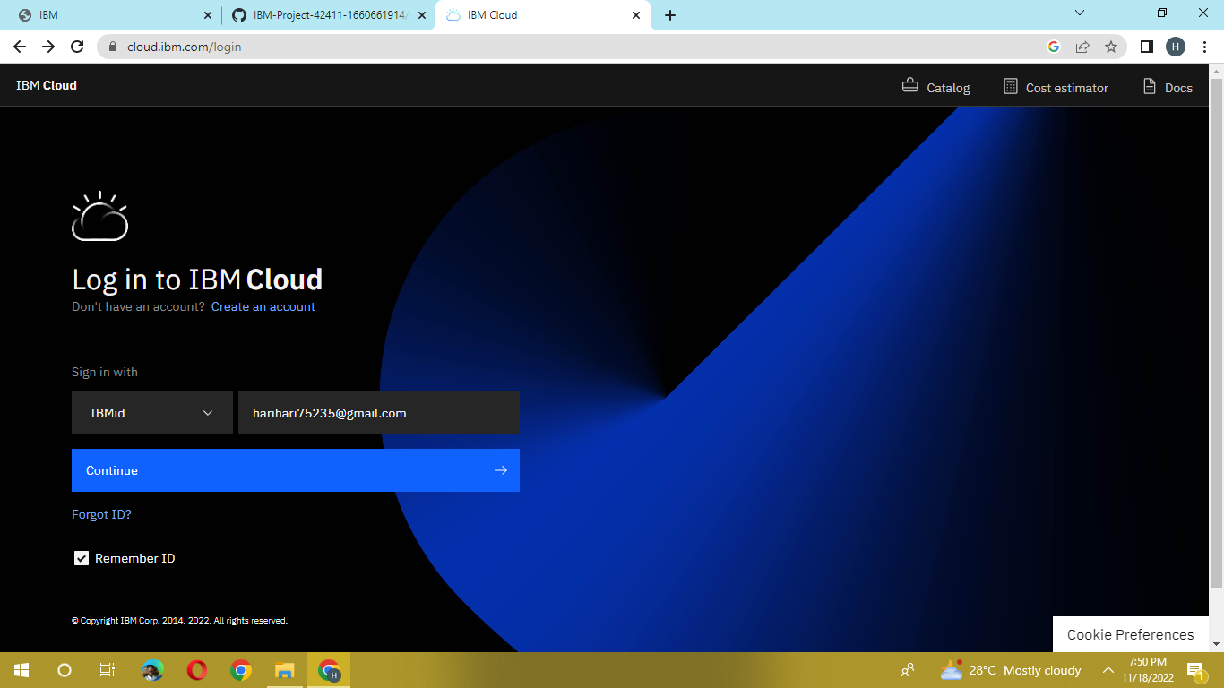

1. Home page of IBM cloud

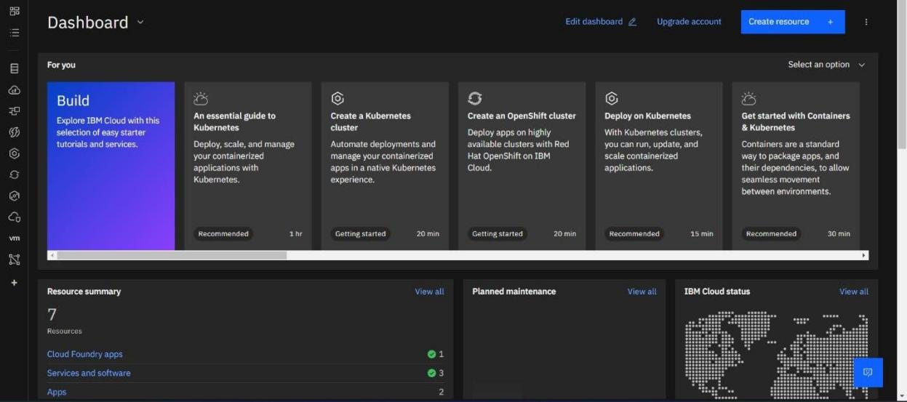

1. Click on the catalog on the top

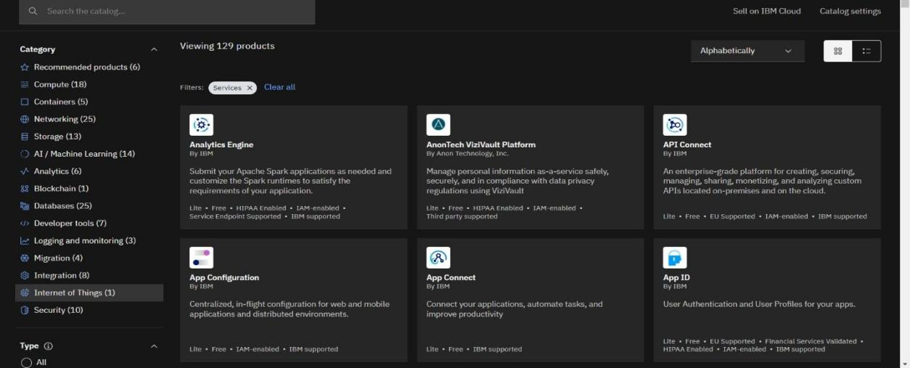

1. Click on IoT in the category mentioned

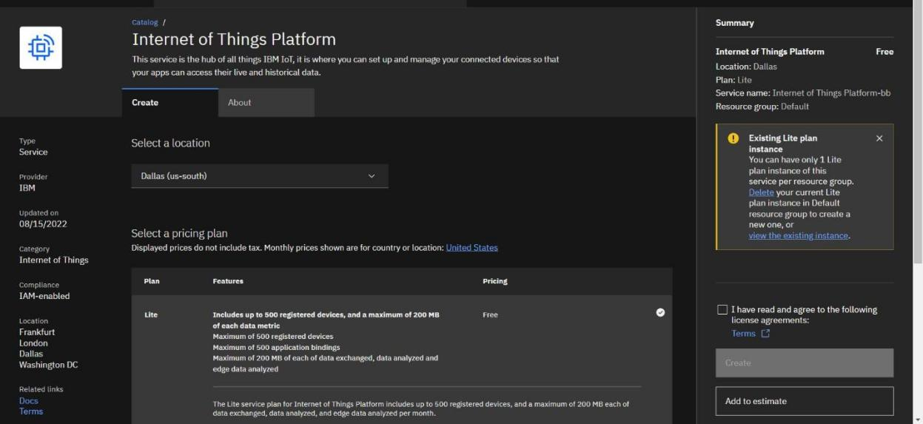

1. If already a lite is present delete it else u can’t create another

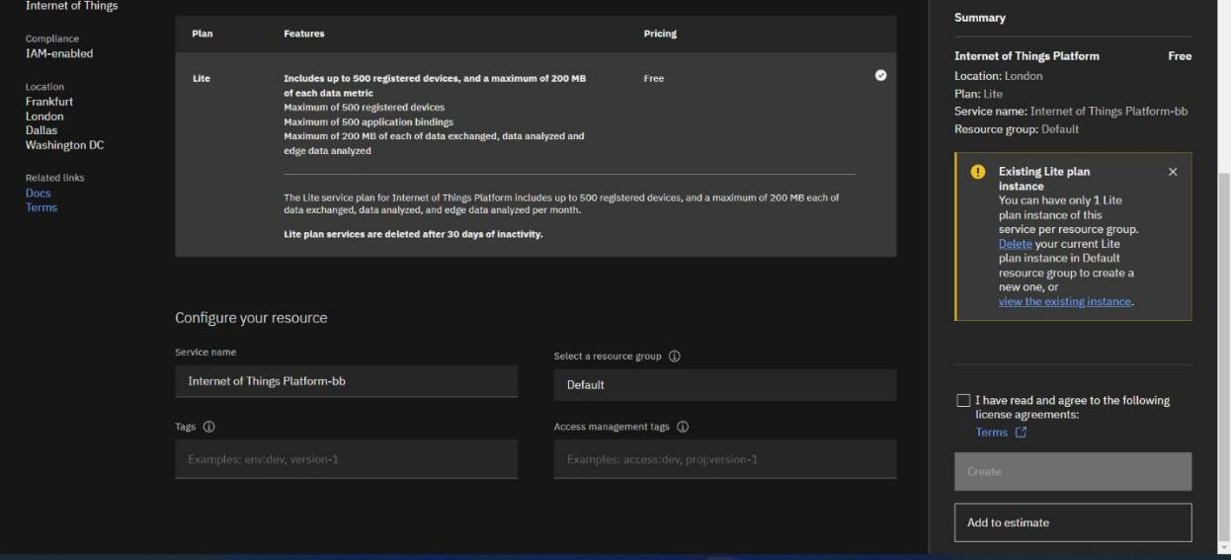

1. Enter the location and in the configure your resource type the service name and choose the plan, tick the agree with agreements and then click on create

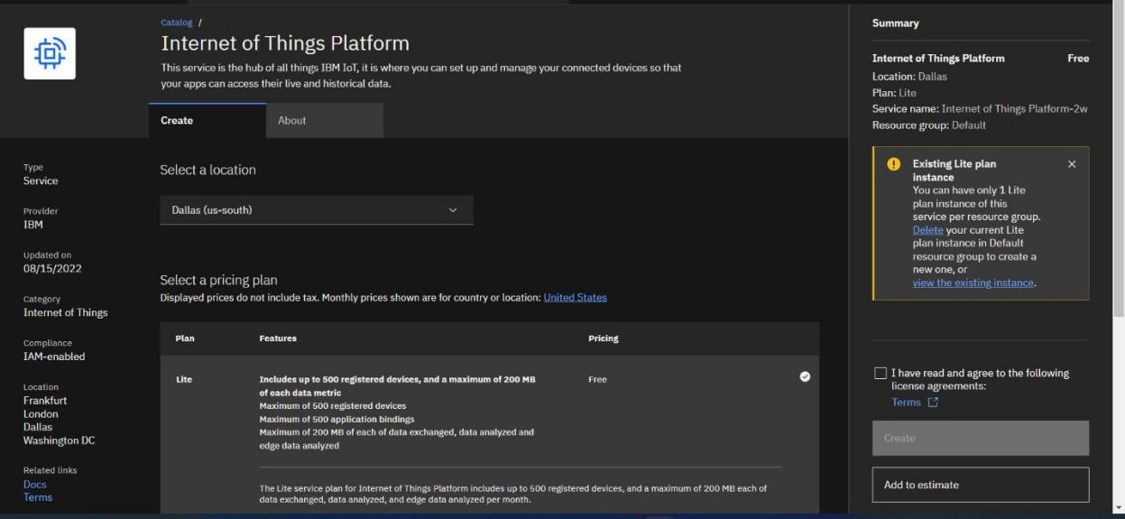

1. click create

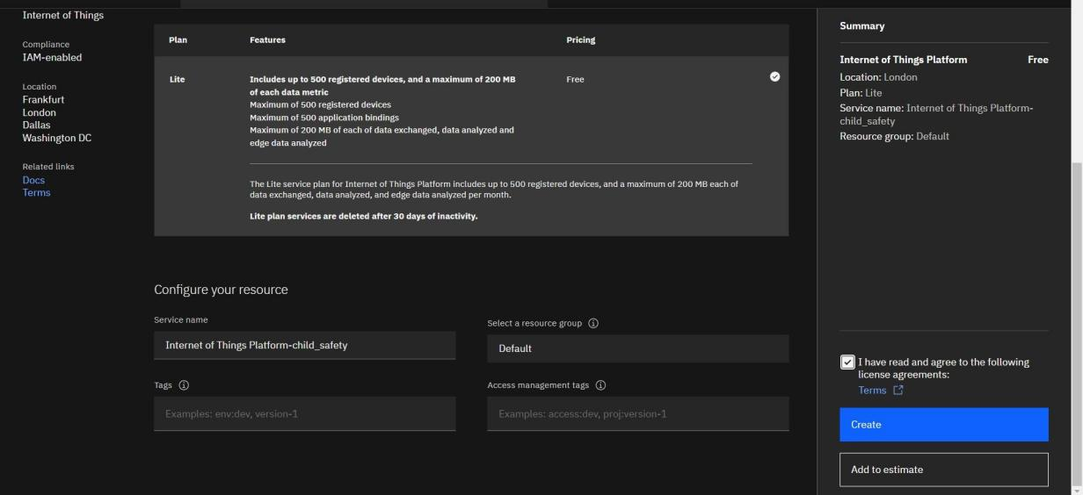

1. Internet of Things Platform Child_safety will be created, where there are different options like manage, plan, and connection

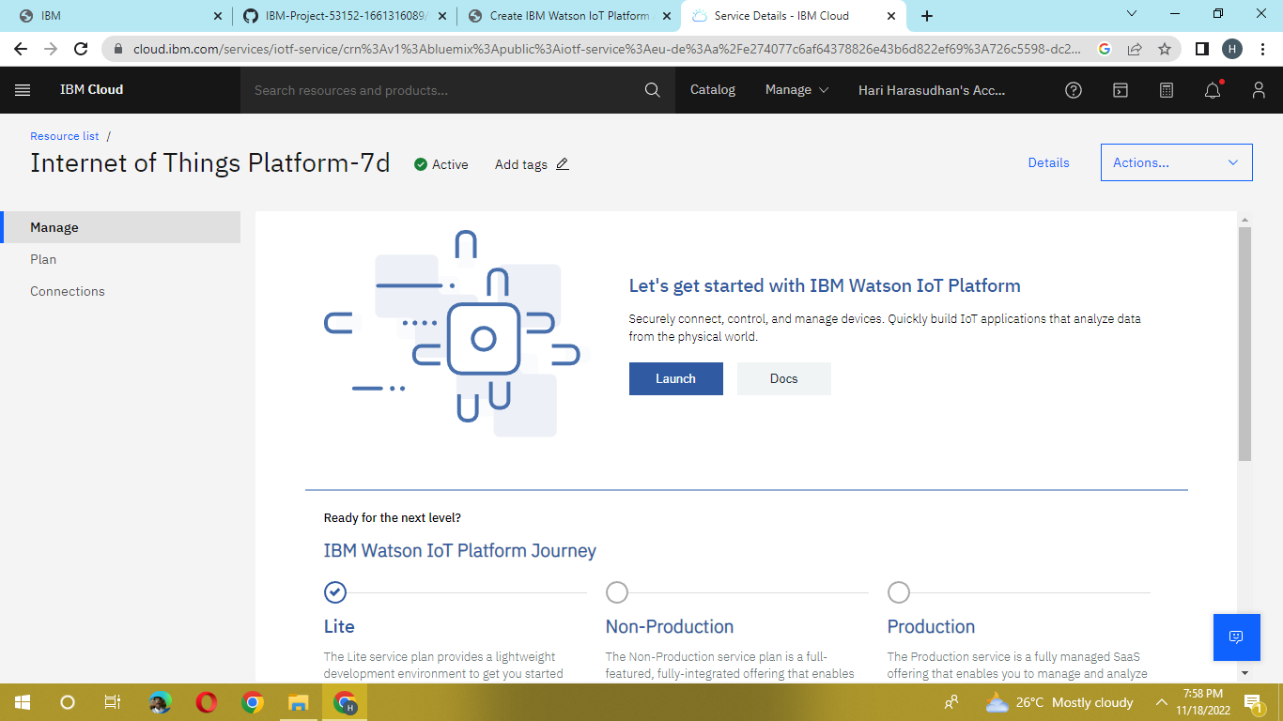

1. manage is for launch, plan gives us the idea about the payment package and its upgrades, and lastly the connection is for to connect IOT with other services

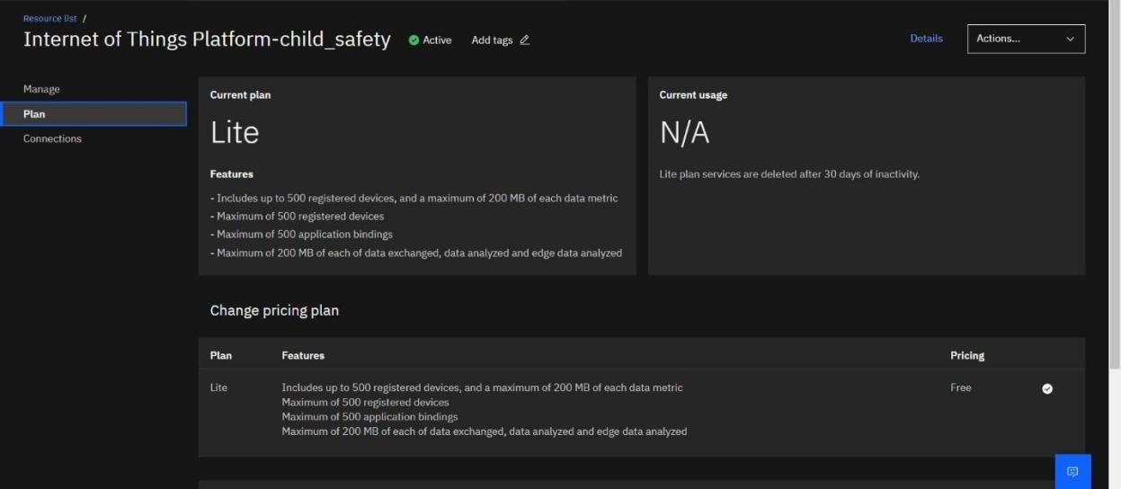

1. Click on the launch button in the manage tab, it will open to this

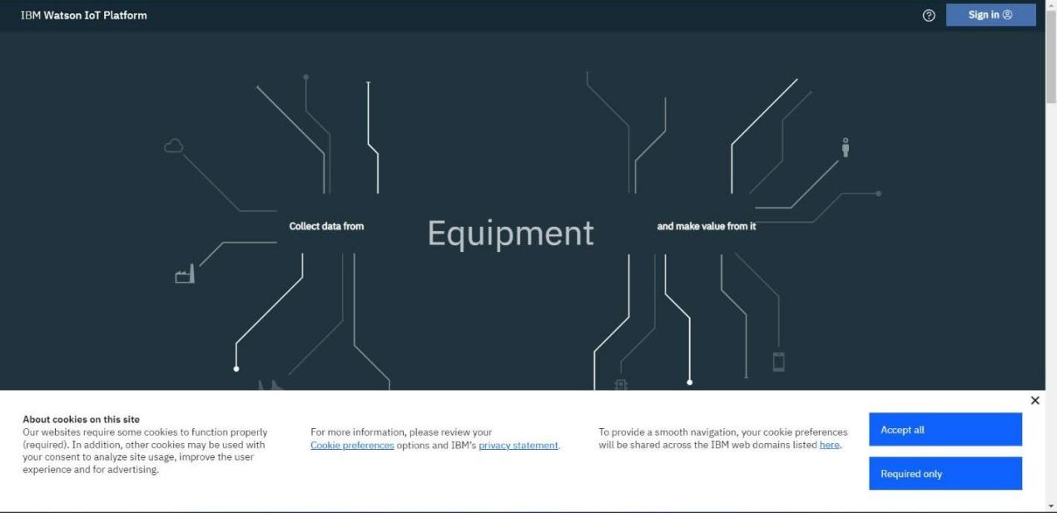

1. Enter the details to sign in to the Watson Cloud to create a device

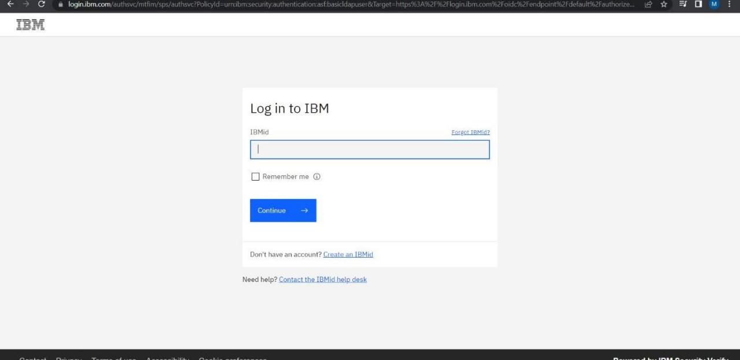

1. Once logged in the name will be displayed and it goes back to the first page

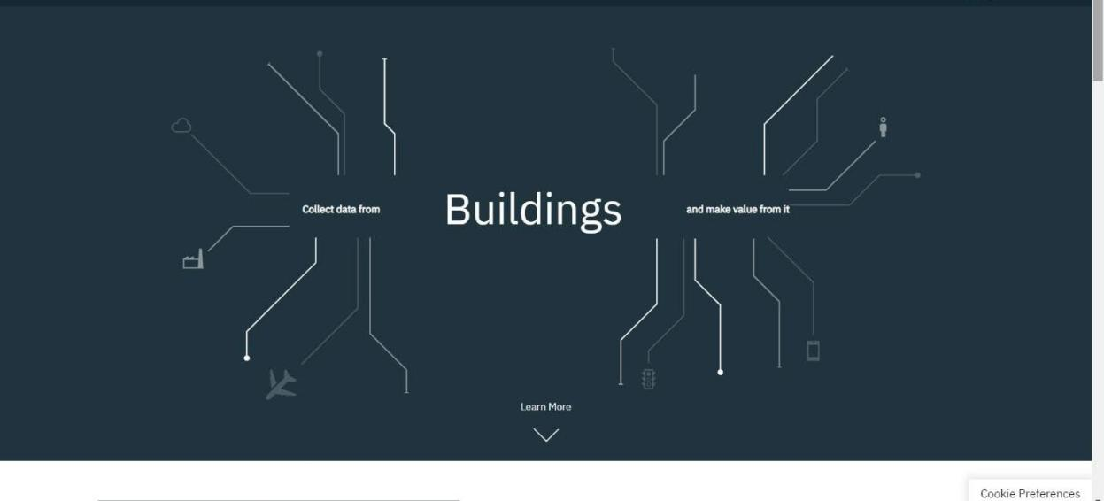

1. And again clicking on the launch button will open this tab, the device will help in the creation of the devices, the addition of devices, and the display of details of the devices.

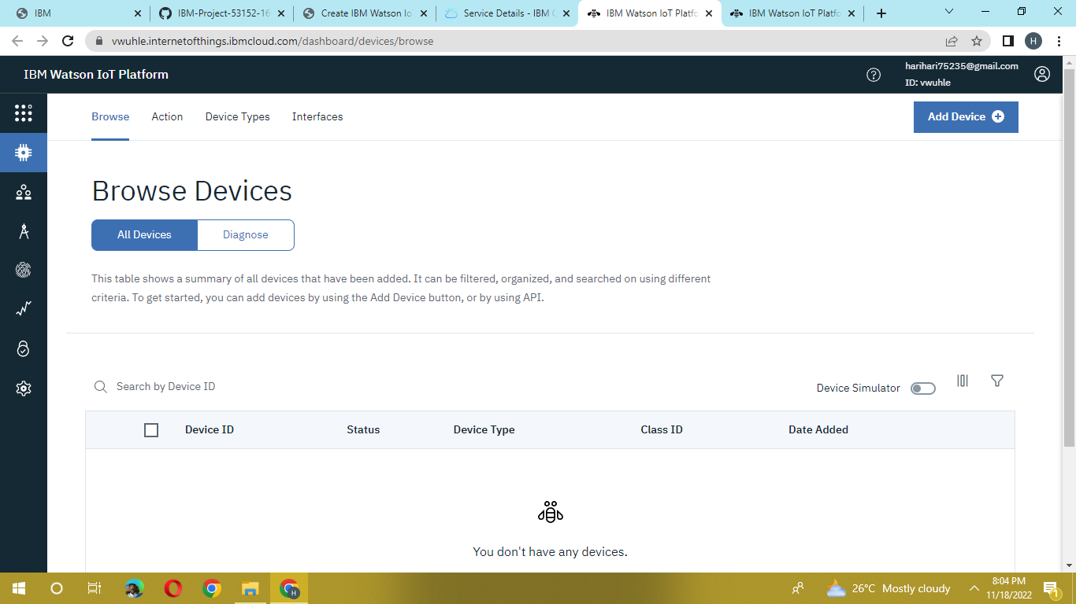

1. The setting tab is used to change the general setting if needed for the project.

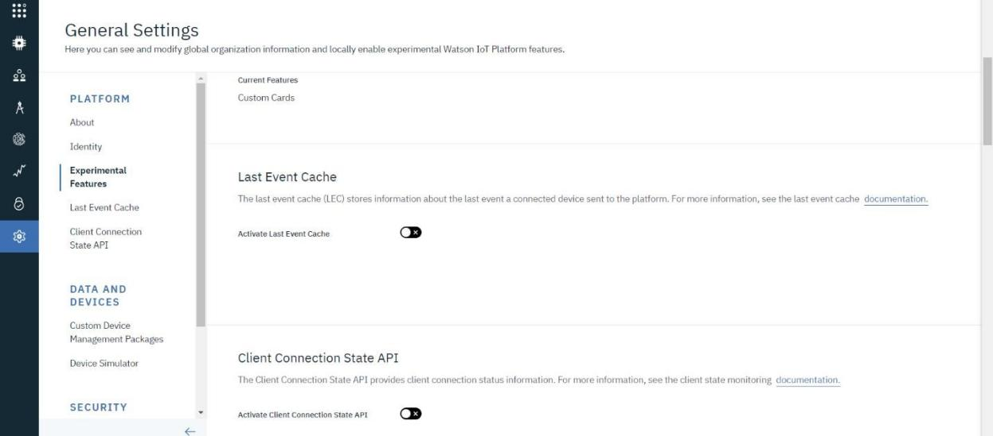

1. In the security tab we can choose the type of security connection and can change according to specification

